INSANE ROOT THEATRE ACCESS DOWNLOAD
INTRODUCTION
Welcome to our Access page! Below you will find a range of resources for our current production: Hansel & Gretel at Arnos Vale Cemetery. If there is anything you think we're missing, and if you'd like these resources in any other formats please do get in touch at team@insaneroot.org.uk
At Insane Root our goal is to make the sites and shows we produce accessible to the widest range of people possible. We will not always get it right and welcome constructive feedback to help us continue to improve with each project.
CONTACTING US
Hannah and Justin (core team) aim to answer all Access queries within 3 working days.
- Email: team@insaneroot.org.uk
- Post: 41 Avon Park, Redfield, Bristol, BS5 9RR
If you would prefer to talk over the phone please email us with a contact telephone and best time to call and we will ring you!
COVID-19 SAFETY
Hansel & Gretel has been created specifically with COVID-19 in mind: featuring small groups, staggered arrival times and an outdoor setting. Mask wearing will be required in all indoor spaces. The site will be regularly cleaned, including spot-checks, with hand sanitizer freely available.

To ensure we keep everyone safe, Insane Root kindly ask you to not attend your performance if you have symptoms or test positive for COVID-19. ​If you miss your booked performance due to COVID-19 we will transfer your tickets to the next available show (subject to availability) or provide free access to our filmed performance. For more information and ticket cancellations, exchanges and refunds, please see our terms and conditions: https://www.insaneroot.org.uk/christmasfaqs.
VENUE & PERFORMANCE ROUTE DESCRIPTION
- Arnos Vale Cemetery is a national heritage site in the heart of Bristol set within 45 acres of stunning woodland. Arnos Vale lies close to Bristol's city centre on the A4 Bath Road, at Brislington.
- There is step-free access to our Box Office team, and to on-site toilet facilities via a ramp and lift.
- Refreshments (hot and cold drinks, food/snacks) will be available to purchase until 9pm.
- This is an outdoor immersive walking production: you will be standing and walking for approx. half the experience, with seats provided for the rest. The performance route takes place partly in woodland paths, partly seated under a roofed structure (benches are provided). The route path includes a mixture of tarmac, wood chip, mud paths and cobblestones. There are a couple of steep inclines, and three stone steps as part of the performance.
- The full audience journey from the start point back to the main gates is approx. 550 m
​
- Regretfully we have been unable to make the on-site show fully wheelchair accessible, but a specially commissioned film version of the production will be available for anyone who is unable to attend in person. This will include captioning and audio description.
ROUTE MAP
The map below outlines the performance paths with distances between stopping points and approximate travel times between each.
- Box Office/cafe is located at the Non-conformist Chapel.
- At Sign 1 the audience will be split into two groups: one following Hansel (blue), the other following Gretel (red). The Hansel path is longer but has a gentler gradient. The purple line indicates where the audience is reunited and travels as one group.
- At Sign 2 there are three stone steps.
- Between the Discovery Trail and Underwood Centre there is a steep hill section lasting approx. 30 m which will be resurfaced at the end of November 2021 so should be smooth tarmac.

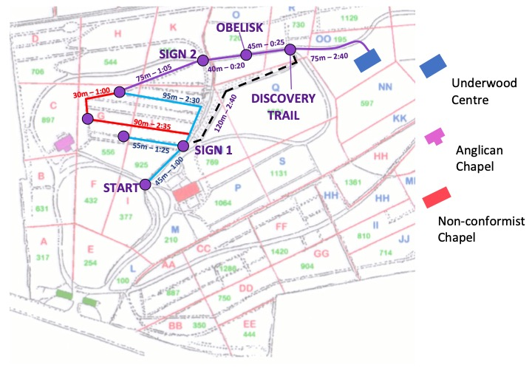WEATHER
This is an open air production and will go ahead even in the case of bad weather, unless we deem the performance route unsafe or if there is a threat to life. We recommend warm clothing, sturdy footwear and raincoats. Christmas jumpers encouraged!
BOOKABLE ACCESS FACILITIES
- Access tickets for Hansel & Gretel are offered at the reduced rate of £10 each
- We offer one free personal assistant ticket per booked Access ticket, for customers who would otherwise be unable to attend
- Free blue badge car parking is available
- All Access bookings must be made directly through the company at team@insaneroot.org.uk
TRAVEL GUIDE
- Accessible parking (blue badge) is available next to our box office and front of house facilities. This is also the drop-off zone for taxis.
- At the end of the performance (in the heart of the woods) there is a 150 m journey back to the main gate, we can arrange for vehicles to collect patrons from a designated end point if this distance would create a barrier for attendance. Please contact Hannah or Justin to discuss this option.​
ARRIVAL GUIDE
- Opening times:
  - Arnos Vale Cemetery is open to the public from 9am - 4pm every day. Hansel & Gretel is a ticketed event which begins once the site is shut to the public.
  - ​Performances take place every 30 minutes from 4pm until 8:30pm. We encourage all patrons to arrive at least 15 minutes before their booked show in order to check in and make use of the facilities.
  - Pre-booked parking permits entry 30 minutes before your performance time and lasts two hours
- Arriving at the Venue:​
  - At the main gate (A4 Bath Road) you will be greeted by a Steward who will check your booking and guide you to your parking (if booked) and / or the box office area.​
  - If you have booked parking, a second Steward will direct you to a parking space.
  - At our box office stall (signposted, by the cafe) the box office manager will check you in to your performance - please bring copies of your ticket invoice(s)
  - If you have any questions, please feel free to approach any member of the Front of House team - we will be wearing yellow or orange high visibility vests.
- Toilets​
  - There is one dedicated accessible toilet, as well as separate Female and Male toilets. These are situated in the basement under the cafe.​
  - Toilets can be accessed via stairs or a lift from the cafe foyer.
  - Should you wish or need to leave the performance to use the facilities at any time a steward will be happy to guide you back to the front of house area and return with you to the performance
CUSTOMERS WITH MEDICAL REQUIREMENTS
- We welcome attendees who need to bring medicines, food or drink to manage a medical condition, or medical equipment. Please contact us if you have any concerns.
- Every audience group (up to 30 people) will be attended by two stewards wearing high visibility vests, if you require assistance please raise your hand or make yourself known to them and they will be happy to help you. We will have at least one dedicated first aider on site, and the team will be in radio/phone contact throughout.
ACCESS TO PERFORMANCE
- All performances of Hansel & Gretel are relaxed: patrons may leave the performance and return (guided by a steward), and we welcome authentic responses to the action: you won't be sitting in a silent, dark auditorium.
- Regretfully, the on-site performance is not fully wheelchair accessible.
- Our online film production will have captioning and audio description
- We will be producing a Visual Guide / Social Story for the production; please let us know if you would like a copy.
ASSISTANCE DOGS
- Assistance dogs are warmly welcome
STROBE LIGHTING
- There is no strobe lighting in the show
TRIGGER WARNING
- This production includes fairytale horror in an immersive setting which some audience members may find intense.
- Key themes: bereavement, child abandonment, imagination, resourcefulness, cannibalism

Thanks for reading!

